**DGMD S-14 Wearable Devices and Computer Vision**

**Final Project Report: Stride Classification**

Video Link: https://www.youtube.com/watch?v=eZLqpIjwU2s

**1. Team Name**

Walking Stride Classification

**2. Team Members and Roles**

Edgardo Rafael Hernandez

Martin Stack

**3. Abstract**

It is intuitive to all of us that having a correct gait is very important.

A small problem in the feet, might change the way a person walks. Even subtle changes in the stride, can cause a chain reaction of adjustments of posture, and walking mechanics. These changes can put stress on the leg muscles, and body joints. Long walks and running, with a faulty stride, increase the risk of developing complications which may lead to more serious problems. That is why gait analysis is very important.

| https://lh3.googleusercontent.com/8WjNUGe1ZWD3Ehy3l100CsKFk0ih95X3EUntDHgsw7IWQhLb8VCmbugzZVIb7e4b4h1q3XO7ZKpAAlA5_yoDDDApxD2HqTQOEgnbw5_p-1n4Vh-zg8-JuKTRGQqyBExSN0ekLrokhttps://lh3.googleusercontent.com/o0z8u7SSvduAwprhS4VtOi8GPScaA8XA8w0etMp5WdU7b4-CGttNX6t9CIX3OoswhnM0ysXFMz7ieorNY8pWIwavqksWOio8A0KEWFWP87FboxadUJDk8K740kLcrJS6Of02g7Yywwwfeetfirstclinic.com | https://lh5.googleusercontent.com/KmXG1dsy8CnBMtTvyskfiCstaD5ul2QPXYxws0__lO7NJZkPHGl0rqbQFfC59LJ7JPkbl8wt9BlUCoomC2-sYKsyjB-vX54FvKIdpGJ7qodlgPFasa5kAgtBFg8m95enYisFFXCOForbes.com |
| --- | --- |

Gait analysis is the assessment of the way a person walks. Usually it is done, using video analysis, by a highly skilled specialist who does the interpretation. Beside the observation analysis, the commonly used tool is pressure plate analysis. Which provides an idea of how the weight is distributed on the feet soles.

| https://lh5.googleusercontent.com/wijXaAHWxsV4wSKxQhlz9xviuvipd0az1E77frN3kUoXrBv4uLH4DU0MQ2iA70u6tlb5ZPV-Pw1dvT1Y2ZHf3uzPmAQzotpYvcEQiLixYyfsQ7AMimh_V2cXReEWFkXlELkyZU88 www.avantitheraphy.com | https://lh6.googleusercontent.com/lUE7X-M9KPduoa0DdNOzBqO8wnRZRCareZAIlr223HtoLXTyvlHLOMAI2BnQRXfpfLegK1xFSBAxvtSraKSog-QpAHCnt9LMOXtsyHjkZbeuSMwr8OKVGAj39WTf6WWWI0IipZs-www.tekscan.com |
| --- | --- |

While the analysis of the stride is a dynamic problem. Current method of diagnosis is not based on movement, it is mainly observational by an expert, and mostly based on weight distribution on a sensing surface.

Using the ST SensorTile fixed to the shoe, we propose that you can detect whether or not your stride is pronating or supinating. The main set of the sensors that we will use for this project are the gyro, the accelerometer, and the compass.

**4. Software and Development tools**

1. **SensiML repository**

<https://app.sensiml.cloud>

1. **Development tools**

Android: SensiML

Windows:SensiML

Cloud:SensiML

1. **Other tools:**

Google Docs

Google Collaboratory

GitHub

**5. Hardware**

Mac PowerBook Pro

Android Device

1 or 2 ST SensorTile Kit

ST Nucleo-64

**6. List of Milestones, week by week**

Week 1:

* Environment set up
* Preliminary Data Collection
* Data Analysis, Final Architecture, and Model Determination

Week 2:

* Data Gathering and Data Wrangling
* Model Training
* Model Deployment
* Prepare presentation

**7. Results and Discussion**

**7.1 Approach**

Using the Sensi ML platform we will classify two types of walking, supination and pronation. Cases of pronation and supination are largely based upon foot size and shape. Flat feet or collapsed arches generally result in a pronated stride. The image of the right is an example of flat feet or collapsed arches. Collapsed arch feet can require specialized orthotics to correct a gate, although most cases do not need medical intervention. (Mayo Clinic)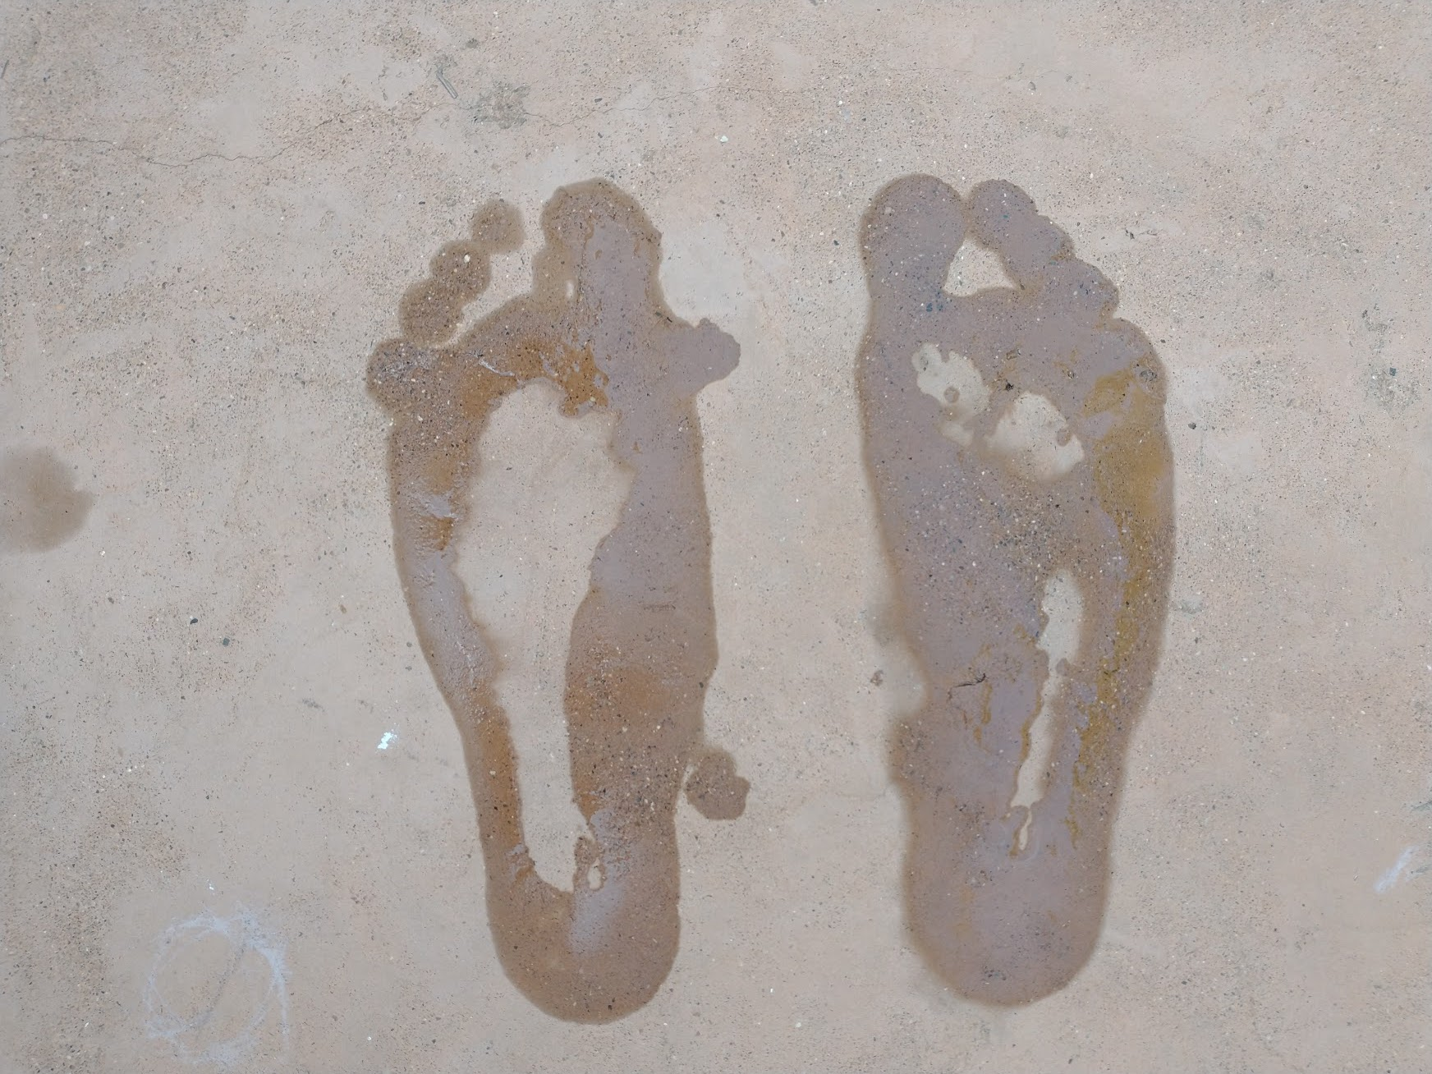

The other example is high arched feet. This results in a supinated stride. High arched feet may need specialized arch supports in the form of orthotics. It is also common to purchase support shoes which have higher arches to correct for the supinated stride. (Mayo Clinic)

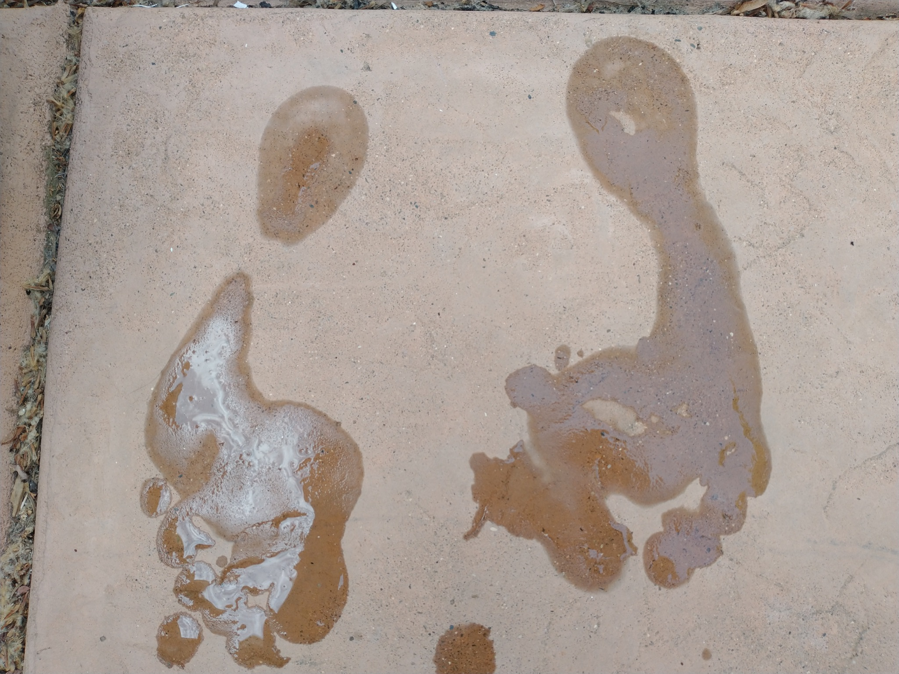

The example on the right shows a high arched foot. This foot results in a supinated stride.

**7.2. Data Collection**

The data was collected by capturing a time series of strides of the flat footed subject and the high arched subject. The styles of classified ambulation were Normal, Supination, Over Supination, Pronation and Over Pronation. Each subject captured 10 seconds of stride, 5 times each. The features of the time series data included 6 degrees of freedom (6DOF), 3 axis of gyroscope and 3 axis of acceleration.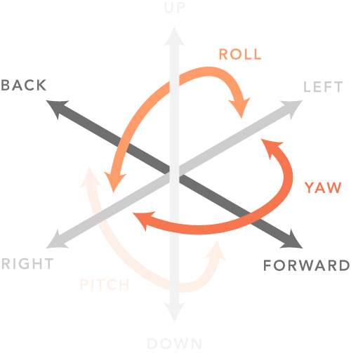

The data was captured with SensiML’s Data Capture app on an Android phone. The Sensor tile was flashed with a basic BLE app produced by the SensiML company which can only capture the aforementioned 6DOF movements. Both feet were captured for a more complete view of stride.

Window sampling generally included the entire 10 seconds of a capture.

This is an example of one of the 10 seconds of data captured. 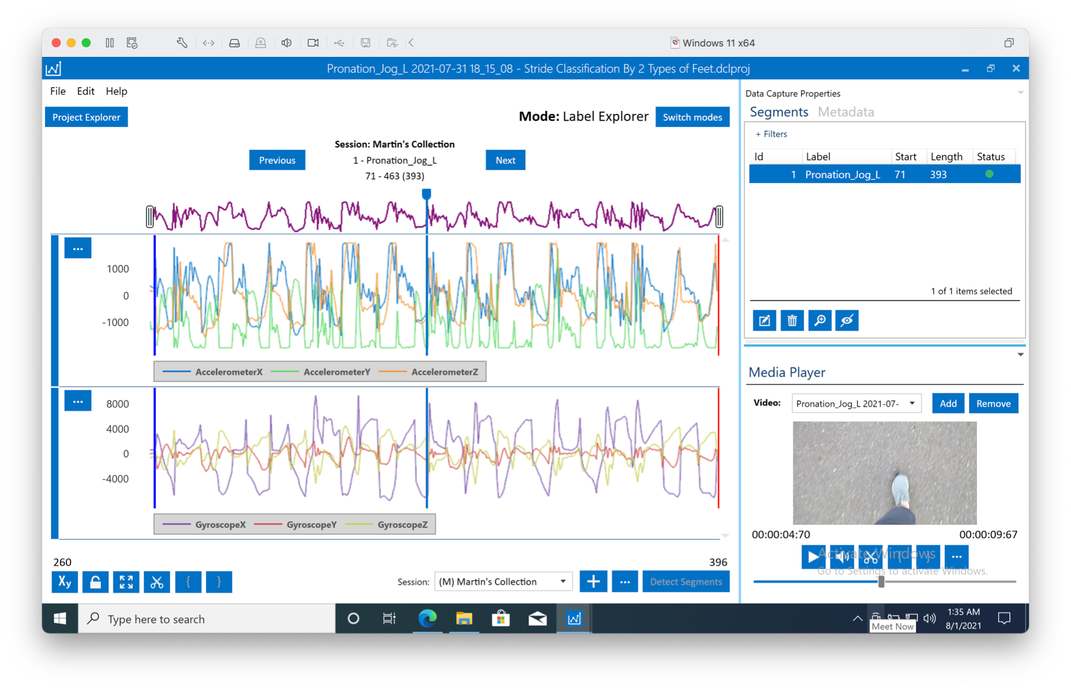

Once the data was labeled and stored correctly, some extra metadata was added in order to annotate the data captured for further classification or query filtering.

Our data was relatively clean due to short windows sizing (10 seconds) captured at 104 hz frequency.

**7.3. SensiML Project Summary**

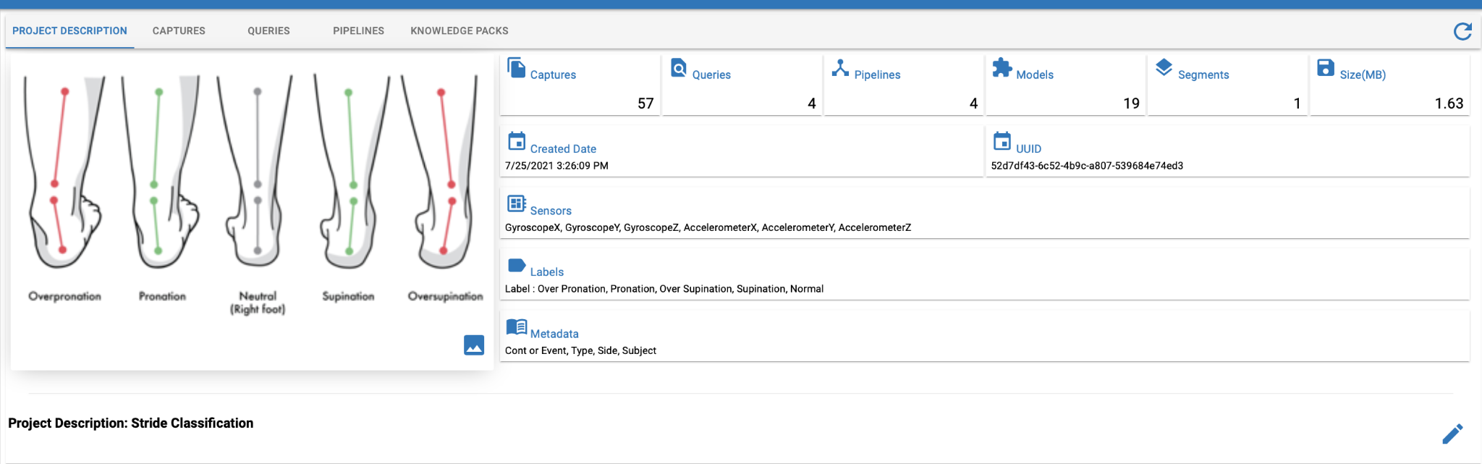

So far, we have:

* Done 57 data capture sessions (Approx. 1.63MB)
* Defined 4 Queries to separate the data
* Created 4 pipelines
* Fitted 19 models (Between 12 Bytes and 10 KB)

The accuracy of the models range between 62% and 99%. All of the models were created using the pipelines applied to the queried data. Many of the models were created using the automatic functions for data processing, and automatic futures generation provided by the tool. The number of features generated range between 2 and 43.

The obtained models are :

* PME - KNN, using RBF optimizer (3 to 9 Neurons),
* Decision Tree Ensembles (Max deep of 4 5)
* NN (Manually created, with 3 Dense layers and 195 params)

**7.4. NN Models and SensiML**

Using the automatic function, for features and model selection from SensiML, we were able to predict with a good accuracy, but below 90%, in order to improve the accuracy and create NN models, coding in Python was necessary, using some functions of SensiMl as a library.

These were the steps we took to create our NN model:

1. **Manually added Features.** A windowing transformation with a window of 250 and a delta of 100 was used. Then the mean was calculated for all the existing sensor data columns.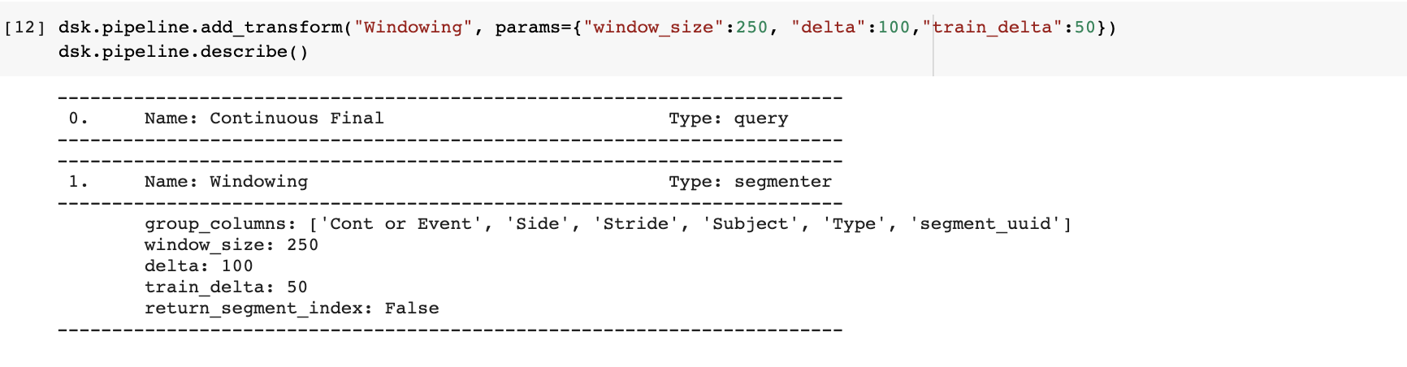

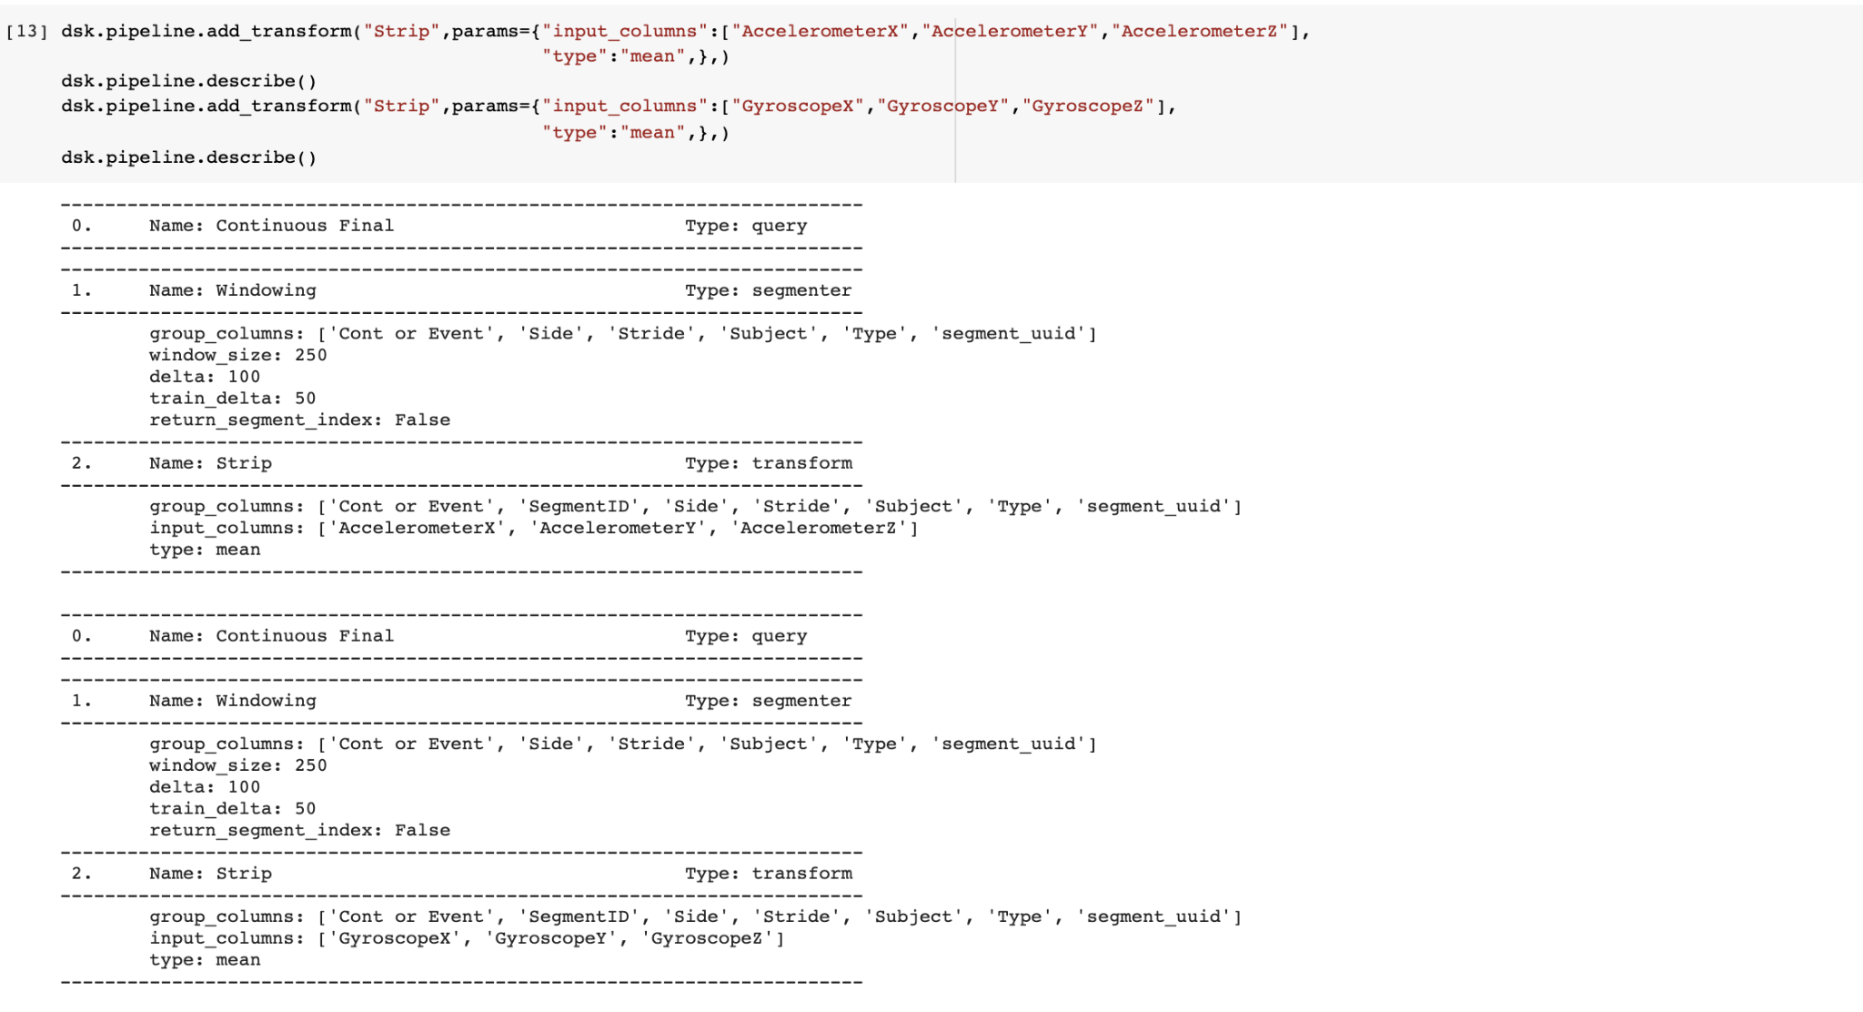

1. **Features added with Feature Generator.** Using 2 of the provided feature generators, Rate of Change & Statistical, we generated multiple feature variables, to a total of 246 columns.

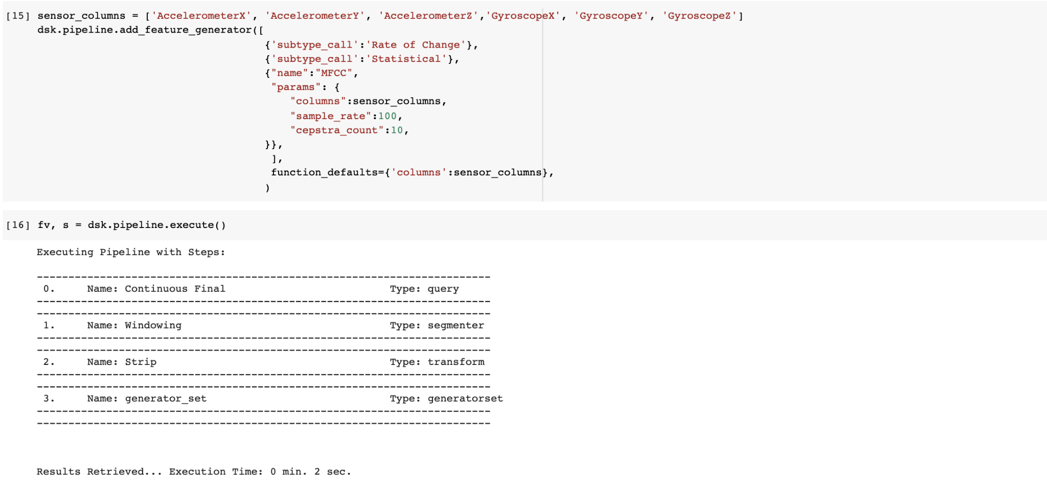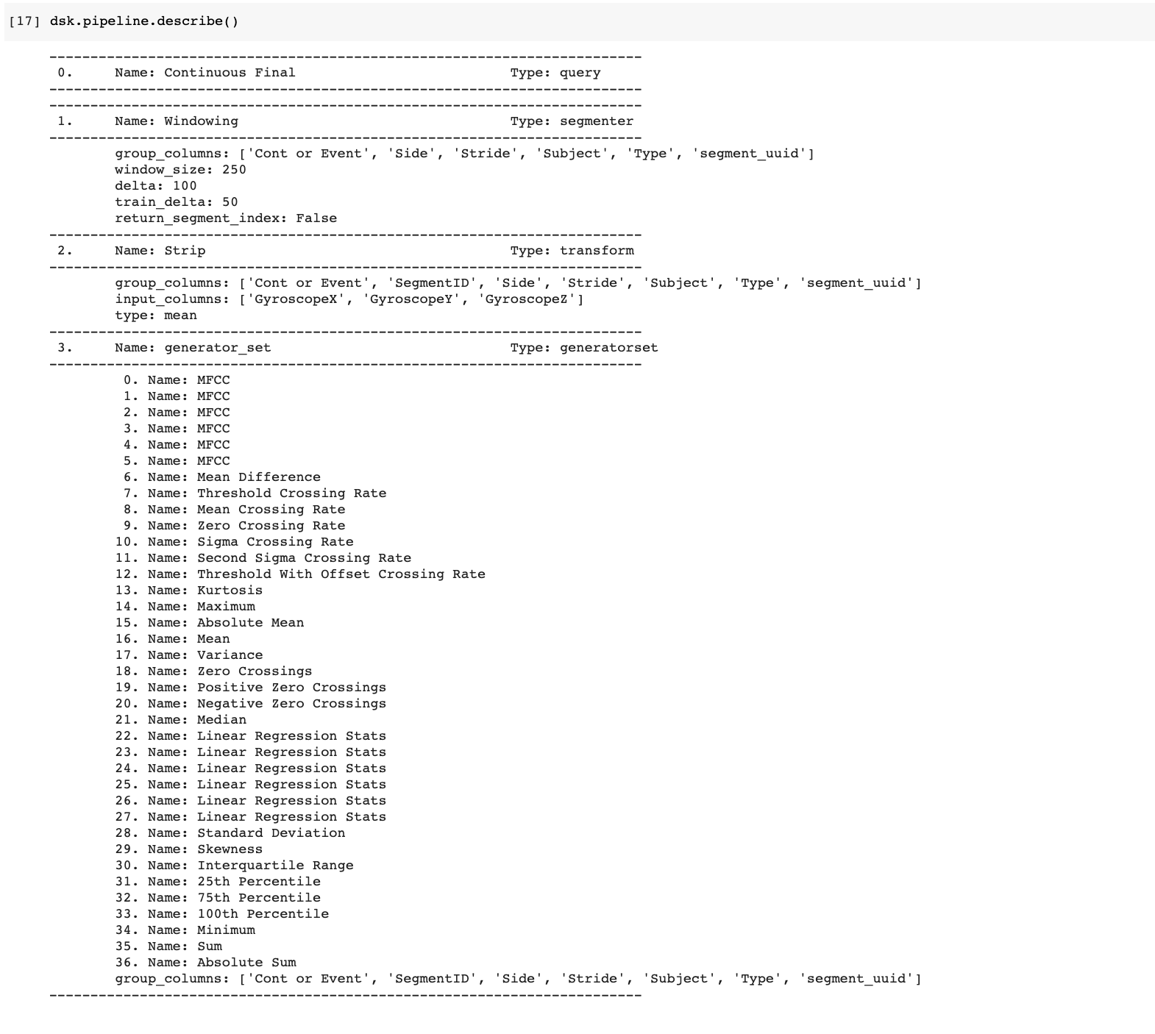 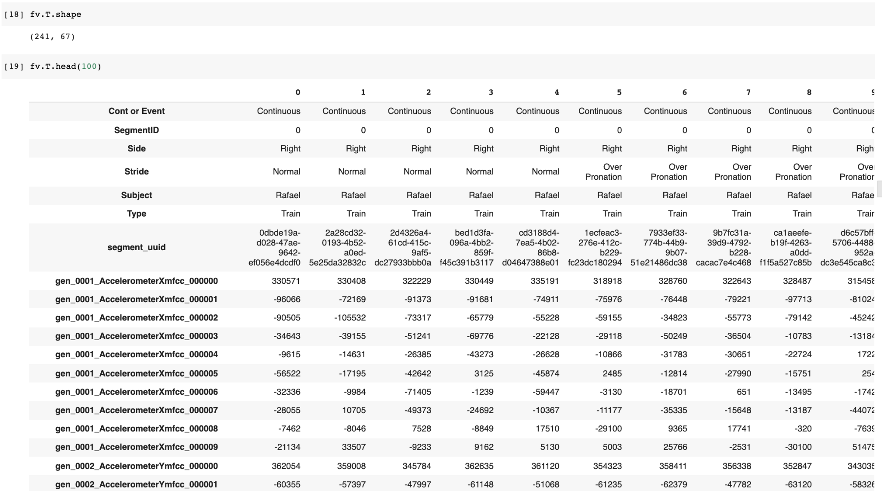

### Feature Selection (using Variance Threshold, Correlation Threshold & t-Test Feature Selector) and Scaling the output data before training the model.

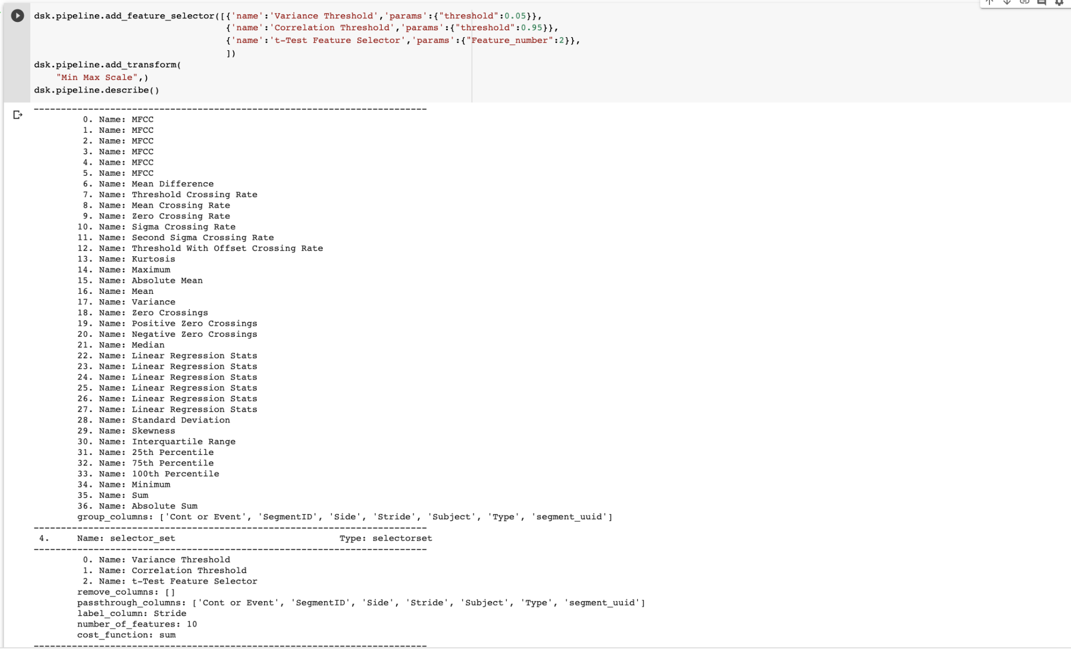

### Significant Features Selected (reduced to a few)

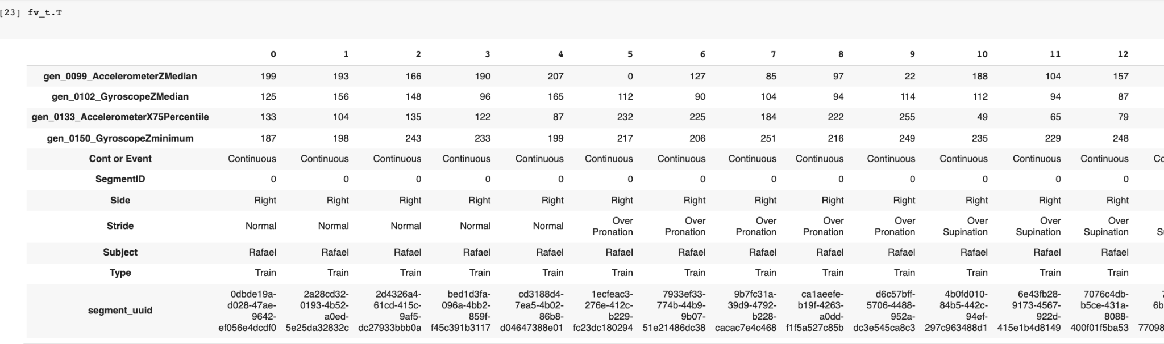 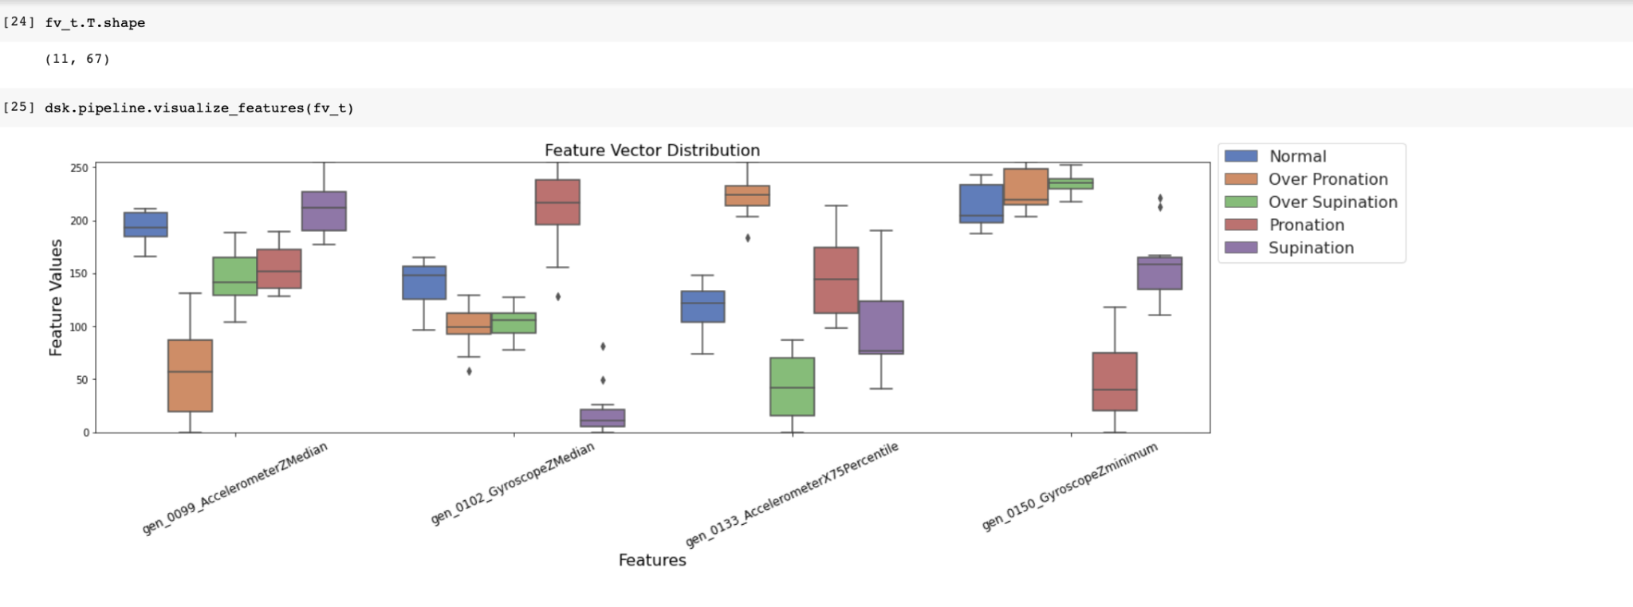

### Creating Train and Test Datasets

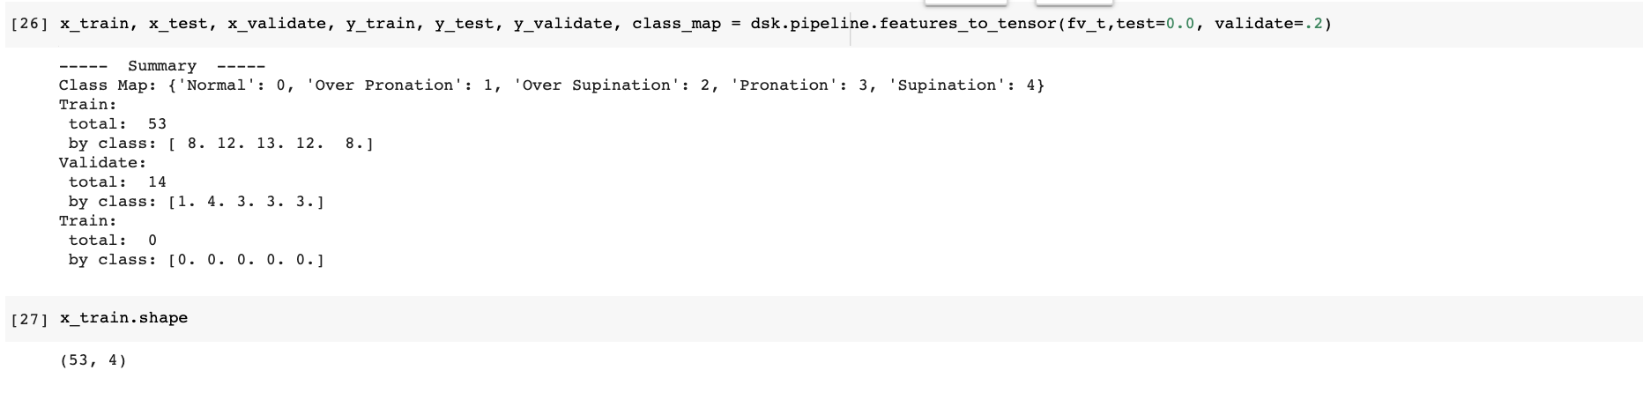

1. NN Model Architecture

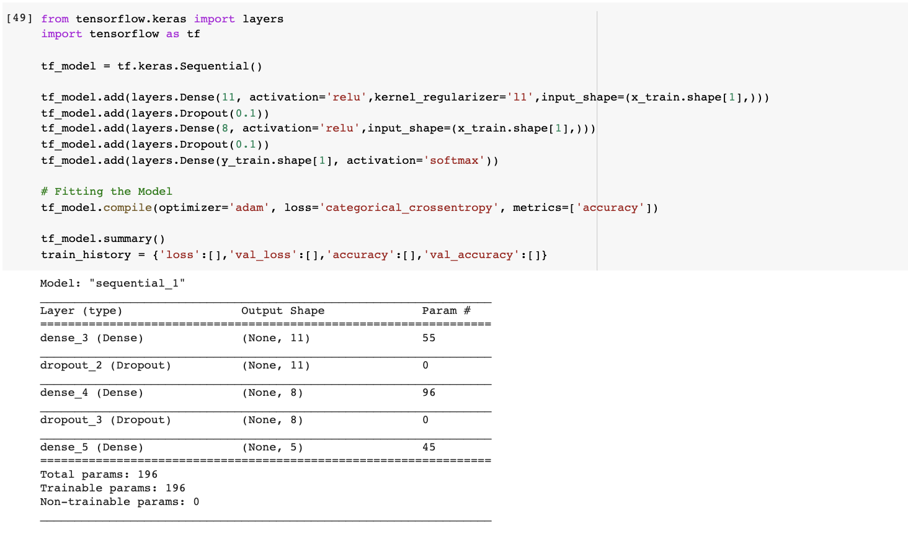

1. Training the Model

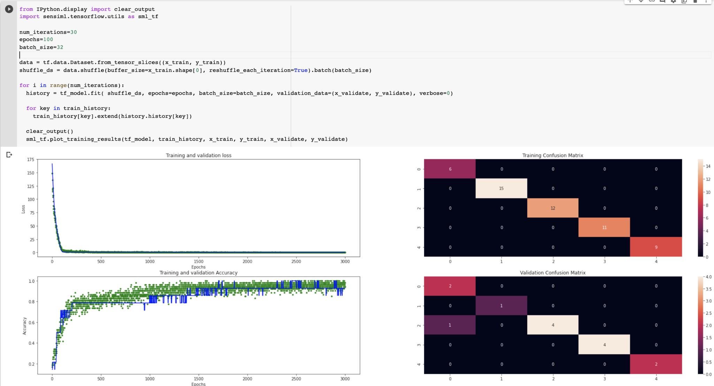 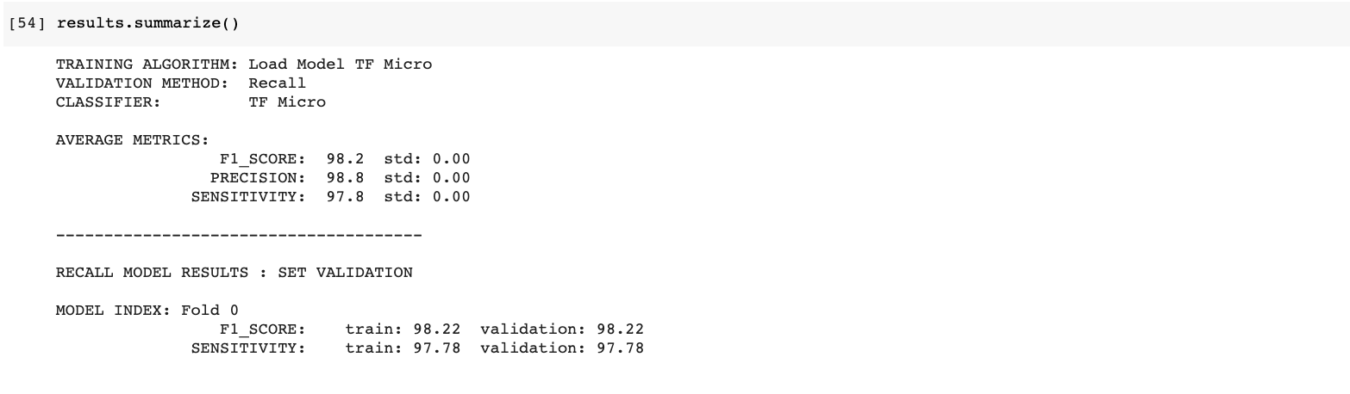 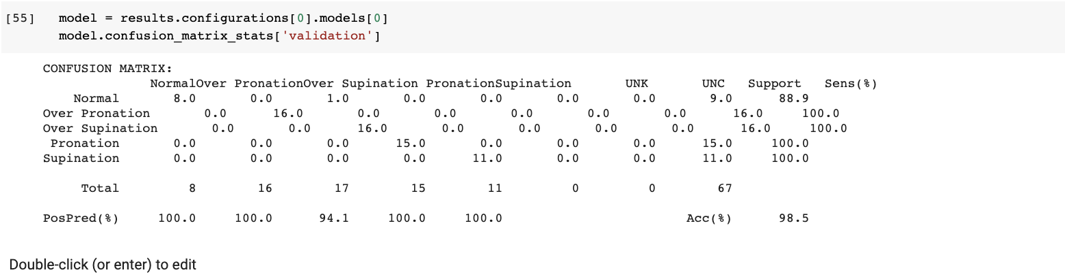

### Quantizing the Model for TFLite

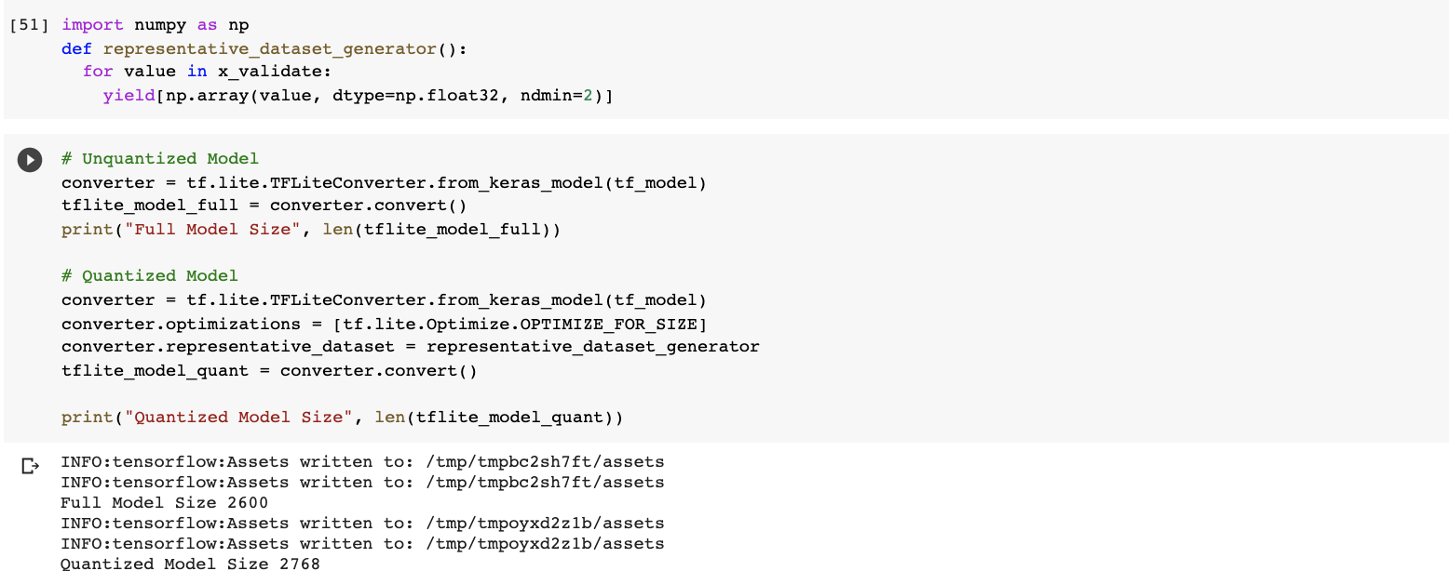

### Uploading the Model Back to SensiML Project

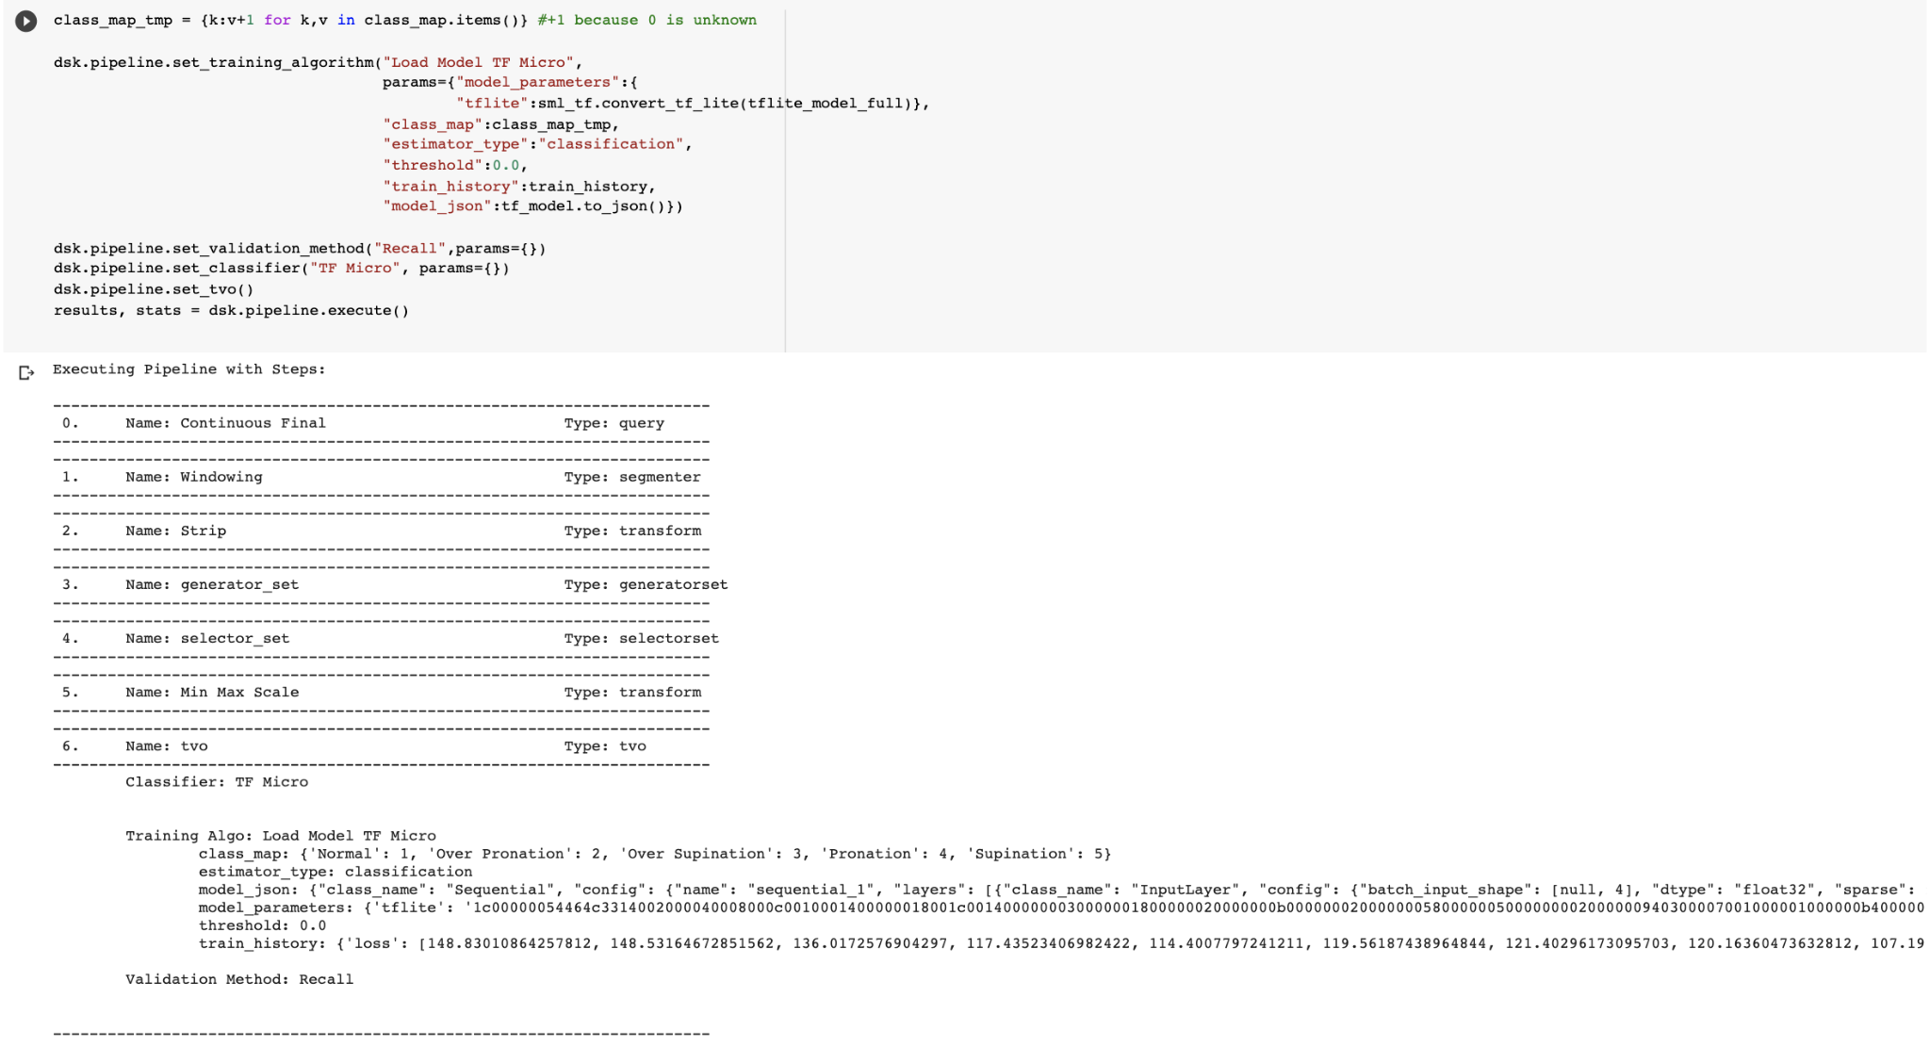

**7.5 Creating the Model Binary for the Sensor**

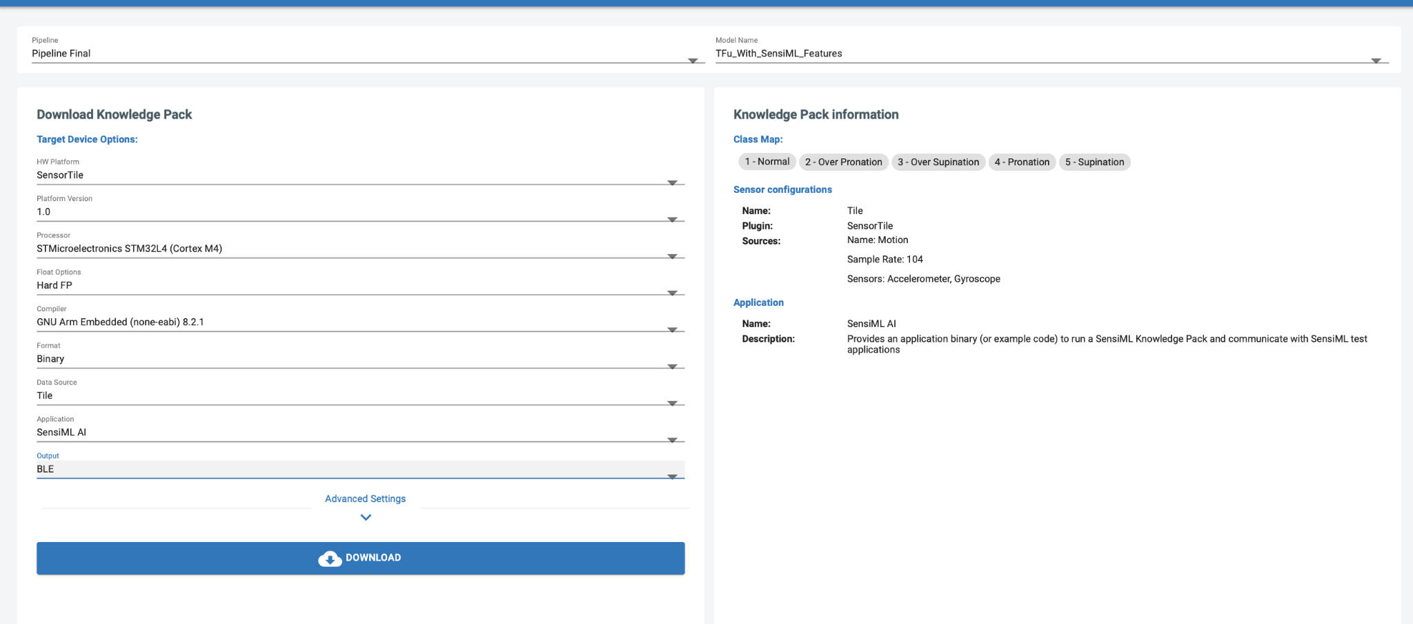

**7.6. Deployment to SensiML App for Real Time Testing**

The application payload includes an Arm Cortex 4 .bin file and a JSON file which stores the model classification parameters that make the result of the BLE transmission from the SensorTile human readable. In order to install the application, first you must first flash the SensorTile to the 0x8000000 region of memory. Then you have to copy the JSON string from the file and paste it into the Android SensiML application. Next, connect the device and start walking. 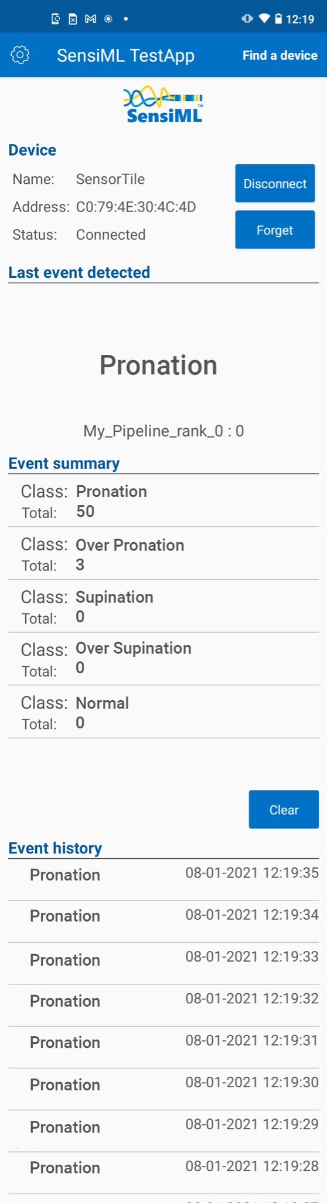

***Note, both Rafa and Martin experienced periodic build issues when downloading the model. Our root cause analysis is inconclusive but we suspect there is an error in the automated build pipeline at SensiML when compiling for the arm cortex 4. We filed a ticket to address the issue with SensiML.

**7. Conclusion**

The ST SensorTile provides adequate data to train and test a model for effective gait analysis. The current cost for professional gait analysis ranges from hundreds to about a thousand dollars. (Mayo Clinic). If our solution could be productised, it could provide expert opinions for a new group of patients that previously were excluded from professional treatment due to a high cost of services and limited physical locale restrictions; due to limited orthopedic clinical offices around the country. The lower costs also could serve communities outside of the Americas where mobile phones are the standard of computing/ communication.

The practice of applying new techniques in computing for artificial intelligence and machine learning is still in its infancy, though it has been widely researched for 50 or more years. The major pain points of this project were a lack of polished developer tools and IT infrastructure around AI/ML. Our research was impeded often by faulty cords, poor soldering and incompatible upgrades in our developer tool chains. An open standard for creating AI/ML should be considered by all involved in the practice of creating AI/ML, in an open democratized environment like the widely accepted w3c standards for web sites and web applications. (W3C)

**8. Future Work**

In order for this model to work more effectively; we need more sample data from a diverse range of people. We should also establish a partnership with a company like SensiML to provide technical support when needed. The initiative would probably have to be funded by an orthopedic organization or a corporation looking to productise the solution. The project would also benefit from a consulting professional who is familiar with getting medical devices approved by the FDA.

**9. References**

Mayo Clinic. “Running - Mayo Clinic Orthopedics & Sports Medicine.” *Running - Mayo Clinic Orthopedics & Sports Medicine*, 2021, https://sportsmedicine.mayoclinic.org/service/running/. Accessed 25 7 2021.

Mayo Clinic. “Flat Feet Treatments.” *Flatfeet - Diagnosis and treatment*, 2021, https://www.mayoclinic.org/diseases-conditions/flatfeet/diagnosis-treatment/drc-20372609. Accessed 25 7 2021.

Association for Computing Machinery. “Smart insole: a wearable system for gait analysis”, *Conference Paper*, 2012, https://dl.acm.org/doi/10.1145/2413097.2413120. Accessed 7 25 2021.

DOI: 10.1145/2413097.2413120

W3C. “About W3C.” *https://validator.w3.org/about.html*, 2021, https://validator.w3.org/about.html. Accessed 7 25 2021.